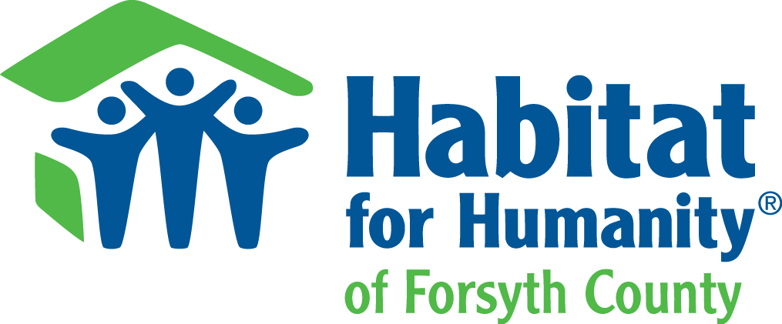

FOR IMMEDIATE RELEASE

FOR MORE INFORMATION:

Mary Alice Holley
maryalice@bcdcideas.com
919-864-0428

BOSTON-THURMOND COMMUNITY CELEBRATED EARTH DAY WITH
A NEIGHBORHOOD REVITALIZATION PROJECT
Community Came Together to Participate in the Event Organized by Audubon NC and Habitat for Humanity

Winston-Salem, N.C. (April 19, 2014) – In celebration of Earth Day, Audubon North Carolina and Habitat for Humanity of Forsyth County partnered to transform the yard of one local family with Audubon’s Bird-Friendly Communities initiative. Volunteers gathered with the family on Saturday, April 19 for a Bird-Friendly Planting Day to install native plants and nest boxes, revitalizing the yard of the Saltiel family while supporting birds and wildlife.

Earlier this year, Audubon’s Bird-Friendly Communities Coordinator and Winston-Salem resident Kim Brand was awarded a $10,000 grant and fellowship from Toyota TogetherGreen by Audubon to lead the creation of bird-friendly spaces as part of the revitalization of the Boston-Thurmond neighborhood. Six homes and two public spaces will be made over with native plants and nest boxes for birds, sparking a revitalization and beautification of the traditionally urban space.

“The driving force behind Bird-Friendly Communities is that simple actions can have a positive impact for birds and people in city-spaces,” said Kim Brand, Bird-Friendly Communities Coordinator for Audubon North Carolina and a board member of Forsyth Audubon. “To us, installing a nest box in your backyard is a small action, but it can make all the difference for a family of birds to survive and thrive for many years.”

The Bird-Friendly Communities partnership program, made possible by a grant from Toyota TogetherGreen by Audubon, focuses conservation efforts where most people live - in cities and towns. Audubon knows that individuals can play a critical role in fostering healthy wildlife populations by making simple, daily lifestyle choices like constructing a nest box or using native plants when gardening. Citizens are given the tools they need to create connected habitats that benefit birds and people from the ground up.

“Neighborhood beautification is a top priority of our organization and our residents, and these neighborhood planting days are important to Habitat for Humanity's new neighborhood revitalization approach,” said Kelly Mitter, operations manager of Habitat Forsyth. “The Toyota TogetherGreen grant and Audubon partnership has given us the opportunity to landscape the yards much more extensively than ever before, creating outdoor spaces that are friendly to people as well as birds.”

Brand added, “What has made the program so successful is the support and enthusiasm from the community and residents like the Saltiel family. David always wanted a birdhouse when he was a child in Puerto Rico, and now he has two!”

With their grants, Toyota TogetherGreen Fellows conduct community projects to engage diverse audiences in habitat, water or energy conservation. To learn more about the conservation efforts of Audubon North Carolina and Toyota TogetherGreen visit nc.audubon.org/bird-friendly-communities.

About Audubon North Carolina
With a century of conservation history in North Carolina, Audubon strives to conserve and restore the habitats we share with all wildlife, focusing on the needs of birds. Audubon North Carolina achieves its mission through a blend of science-based research and conservation, education and outreach, and advocacy. Audubon North Carolina has offices in Corolla, Boone, Wilmington and Chapel Hill.

About Habitat Humanity of Forsyth County
Since its founding in 1985, the Habitat Forsyth affiliate has completed more than 350 homes for local hard-working partner families. Currently, our Neighborhood Revitalization program is focusing on homes within the Boston-Thurmond community by continuing its traditional model of building new houses and working with residents to rehabilitate existing homes.

About Toyota TogetherGreen By Audubon
Toyota and the National Audubon Society launched the Toyota TogetherGreen initiative in 2008 to foster diverse environmental leadership and invest in innovative conservation ideas. Toyota TogetherGreen funding recipients have improved more than 30,000 acres of habitat, mobilized 420,000 individuals, conserved 15 million gallons of water and leveraged $10.5 million in volunteer hours. For more information, visit www.togethergreen.org.

###
.

